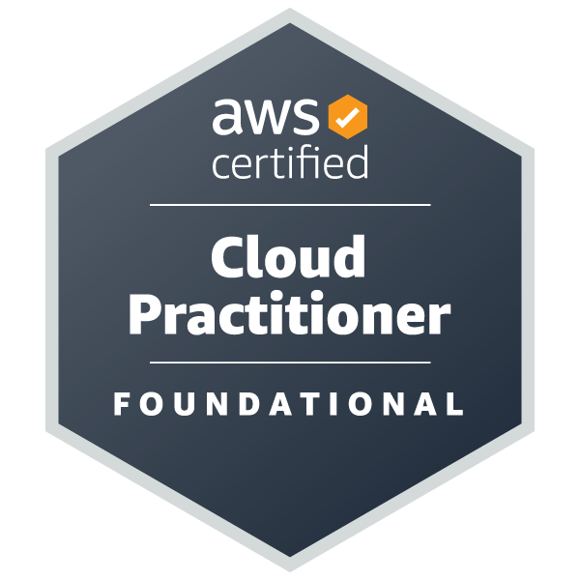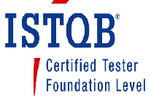
SOWMYA BHATT Dasanakodge

201-850-3508
sowmya.dasanakodge@gmail.com
Professional Summary
Certified AWS and ISTQB QA Automation Lead, having 13 years of experience in working with Software development teams to develop excellent quality features for Web application, REST API, Windows application, Database and AWS. My expertise is Requirement Analysis, Identifying and resolving issues, REST API testing, Automation testing using different tools like selenium, karate, Cypress, Fitness, JMeter, Cosmos DB, Dynamo DB, Load Runner and Postman. Worked on Healthcare, Insurance, Logistics, Trading, fintech and SaaS.
Skills

- Testing Tools: Selenium Web driver, UFT/QTP, Jenkin, GitHub, Extent Reports, TestNG, Cypress, Postman, Karate, JMeter, Blaze meter, Load Runner, Junit | - Tools: JIRA, Quality Center, Bugzilla, PractiTest, Serena business management, Share point, Swagger and confluence.
- Data bases: Mysql, Microsoft SQL Server, Cosmos DB, Dynamo DB and oracle. | - Application: Web, Mobile, Windows, API, Microservices, AS400, Mainframe, AWS, Azure Devops.
- Programming Languages: Java, VB script, SQL, HTML, XML, CSS and JSON | - Domain: Health Care, Logistic, E-commerce, Networking.
Experience
Client: Fidelity Investment, Durham, NC- Remote
QA Automation Lead Engineer-Senior SDET Mar 2022 -till

- Experienced with automating UI, REST APIs, web services and back-end processes.
- Worked on ETL testing using ICEDQ tool.
- Experience with Selenium, Karate and Cypress automation tools with java and javascript.
- Acts as a conduit between on-shore and off-shore teams, share the work and assign work to team members.
- Plan and prioritize QA team hand-on/offs process on daily basis, supporting and guiding the QA team resources.
- Work with team members to resolve testing issues impacting the QA deliverables.
- Create, maintain, and manage test data, using test management tools.
- Socialize QA strategy, QA Test plans, and ensure that best practices are implemented and adhered to
- Activity participates in scums meeting and provide, refine QA estimations.
- Responsible for test execution and QA support in test and stagging environments
- Primary POC to perform sanity testing and provide production check-out support, once in two weeks.
- Have Test Automation experience and exposure to selenium and Continuous Integration tools for CI/CD/CT pipelines.
- Strong Experience on Automation of Angular JS web Applications and Page Object Model Framework and Integrated with ICEDQ.
- Good understanding of backend DB systems and general database querying knowledge
- Have lead QA team members on QA deliverables, time tracking, coaching, and feedback.
- Summarize test results and report the metrics on a daily and weekly basis to leadership teams.
- Experience delivering high-quality products and facilitating automation tests in enterprise software environments.
- Experience in developing or influencing the development of automated framework(s) for enterprise-level functional and regression testing is preferable.
- Excellent knowledge of software development lifecycle, test methodologies, and tools, and passion for quality processes.
- Establish and improve test automation, QC, and UAT processes and standards across the program.

Client: ConnectiveRX, Whippany, NJ - Remote
Automation Lead Engineer-SDET Oct 2019 ‐ Mar 2022

- Designed the automation framework for the enterprise level in Java programming language using page object design pattern and Hybrid framework for all the Web application, Microservices, DB testing using different tools like Selenium, UFT and Karate.
- Overseen UAT process to gain sign-off on releases.
- Lead on- and off-shore QC teams in the planning and execution of testing activities.
- Managed on shore and off shore QA team and delivered the project successfully.
- Lead and mentor a team of QA engineers, providing guidance, training, and performance feedback to ensure the growth and success of the team.
- Mentor and guide QC, Business, and technical team members on proper requirement creation and testing process
- Responsible for leading and managing QA team for automation testing and identifying and converting the manual test cases into automation scripts.
- Responsible for testing the product using SQL queries for Database validation.
- Work with Data teams to establish test data creation processes across environments.
- Extensively worked on REST API testing for component level scenarios.
- Extensively worked on automating in AWS cloud computing for Dynamo DB, S3 and Lambda using selenium with Java.
- Experience in Azure devops for deployment.
- Hands on experience automating Angular JS application and Rest API.
- Developed end to end automation framework using Selenium, TestNG, Maven, page factory, extent reports, GitHub, and Jenkins.
- Establish and evolve formal QA processes for automation, ensuring that the team is using industry-accepted best practices.
- Design and Develop the Automated solution for Smoke Testing and regression testing for various repeatable tests.
- Implement QA process for Automation for all the projects to improve the overall utilization of automation scripts.

Client: UPS, Parsippany, NJ, USA
Computer programming analyst -SDET Jul 2016 ‐ Sep 2018

- Responsible for end-to-end QA testing and development and execution of automation regression script.
- Experience with HP Load Runner, JMeter for performance testing.
- Responsible for identifying test cases for manual and Automation for Smoke Test, Functional and Regression Tests.
- Created a Hybrid Framework of automation for the windows application in UFT using VBScript for windows application and developed automation scripts using selenium Java for Web based application.
- Created executable batch files to open multiple applications using VB script on a newly built machine.
- Actively participate in all the testing like writing test cases, identifying the edge case scenarios, execution, publishing reporting and all the Sprint activities.

Client: NYC HRA, Brooklyn, NY
Computer programming analyst Jul 2015 ‐ Jun 2016

- Responsible for end-to-end testing and delivery of a core module in ICE application.
- Actively involved in requirement elicitations and acted as Single point of contact (SPOC) for all testing releases and operations.
- Formalized testing process and created test cases, identifying the scenarios, raising a requirement defect.
- Worked actively with Business stockholder, business analysts and developers to collect the business and functional requirements.
- Communicate, collaborate, and coordinate day to day testing activities in accordance with appropriate standards, methods and procedures and provide status on issues through testing metrics and dashboards in a timely fashion and manage escalations appropriately.
- Work with architects, development and UAT teams to manage the dependencies and risks pertaining to testing efforts.

Client: UPS, Paramus, NJ, USA
Computer programming analyst Nov 2012 ‐ Jul 2015

- Extensively worked on testing and Automated AS/400 mainframe application using Terminal emulator in UFT/QTP.
- Design and Developed Hybrid Driven Test Automation Framework using UFT/QTP using VB script, worked on custom function, shared object repository, and descriptive programming.
- Extensively worked on mobile application and worked on creating critical end to end enterprise scenarios based on production issues.
- Created and Executed Automation Test Scripts for Functional and Regression Testing.
- Automated test scripts which were extensively used for backend validation.
- Used driver script to navigate the test data variables by using VB Script in UFT.
- Worked on batch file to run automation script on Task Scheduler in Windows.
- Involved in testing UDP and MQ messages.
- Involved in testing web services using SOAPUI.
- Involved in creating end-to-end scenario for testing.
Client: Century Link, Bangalore, India
Software Engineer Jun 2010 ‐ Apr 2012

- Extensive experience in reviewing and analyzing Business Requirements and creating Test Plans, Test Cases, Test Scripts, Test Estimation & Requirement Traceability Matrix (RTM).
- Professional expertise in Smoke Testing, Backend Testing, User Acceptance Testing (UAT), Functional testing, Positive/Negative Testing, System Testing, Regression Testing, GUI Software Testing, Ad hoc Testing, Cross Browser/Platform Testing, UI Validation, Boundary Value Testing.
- Reviewing database test cases according to assigned Requirements to validate reports by retrieving data with SQL queries from oracle database.
- Involved in automating on the regression test cases for e-Commerce sites including Checkout Process & Registration process, user account using UFT/QTP.

Neurosynaptic systems, Bangalore, India
Testing Engineer Aug 2009 ‐ May 2010
- Worked on network protocol testing for weather data transmission.
- Extensively performed business workflow, ad hoc, regression, functional, integration, release and database integrity testing based on system test cases.
- Interacted with the developers and project team on day-to-day basis to discuss about the defects and to make sure the reported defects were resolved.
- Actively involved in requirement elicitations and acted as Single point of contact (SPOC) for all testing releases and operations.
- Involved in Functional study of Application, Prepared work distribution plan for the team, performed gap analysis and documented them.
- Developed Requirements Traceability Matrix (RTM) to map the test cases with the Requirements.
- Generated various test metrics and shared with the Project Manager.
Education
AWS Foundation certification June 2023
ASTQB foundation level certified Jan 2014
Bachelor of Engineering in Computer Science Jan 2009
Global Academy of Technology

